Cash register module

# Bref of database structure

Cash forms are defined in control data CASHFORM, active cash form has V1=1

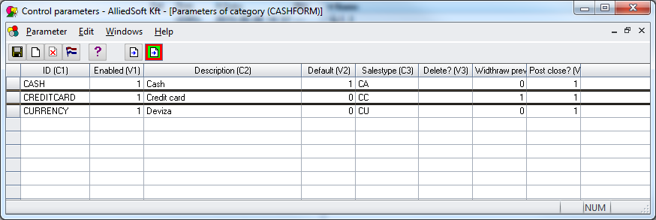

Cash types are linked with Cash form, and stored in table CASHTYPE

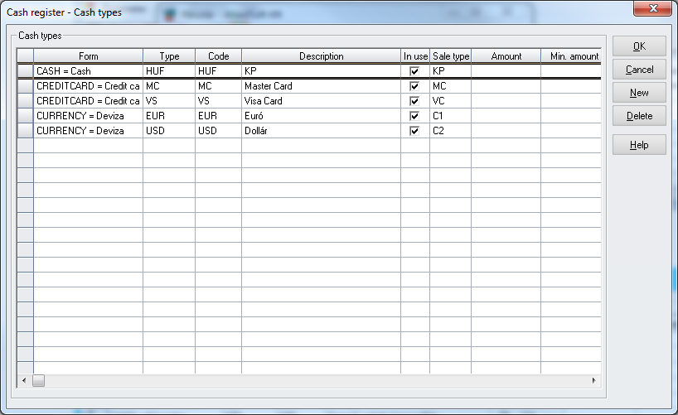

In above screen 2 credit card types are linked to CREDITCARD form, and 2 foreign currency EUR and USD are linked to CURRENCY form.

There are several cash boxes in a site, the cash box are defined in control data CASHBOXID.

Important: all necessary voucher ids must be defined in NUSE table !

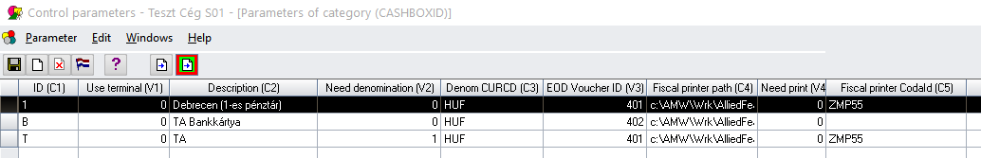

V2: if 1 then when closing cashbox the denomination is showed and the cashier must count and put the correct amounts until the total matches the balance.

C3: The denomination currency

V3: Voucher id when closing the cashbox, CASHREG.EOD_RECEIPTNO

V4: If =1 then SSRS receipts will be printed, in this case C4, C5 is not used

If = 0 then C4: the mapped drive where the fiscal file will be printed, C5 : control data contains information about the fiscal file format , depends on the type of fiscal printer (**Currently only Datecs MP55B is supported, FP550 is almost done and under beta test**)

V6: Is virtual ? If virtual then anybody can use this cashbox, not only the person who opened it.

V10: EnableFee ? If yes then a Fee field will be enabled in the Payment window.

CASHREG control data : common settings for cash register

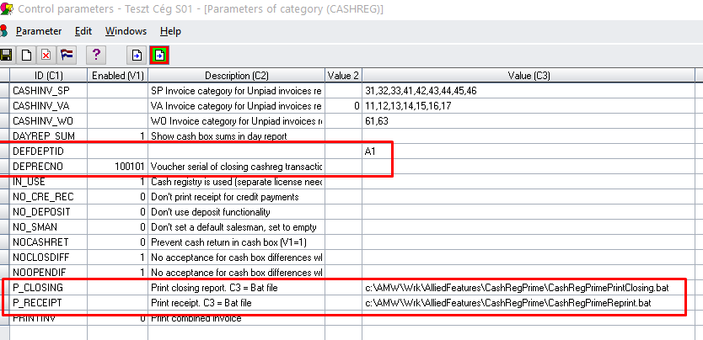

DEFDEPTID : default department

DEPRECNO : CASHREG.RECEIPTNO

P_CLOSING : bat file will be called when closing cashbox

~~P_RECEIPT : bat file will be called when making payment~~

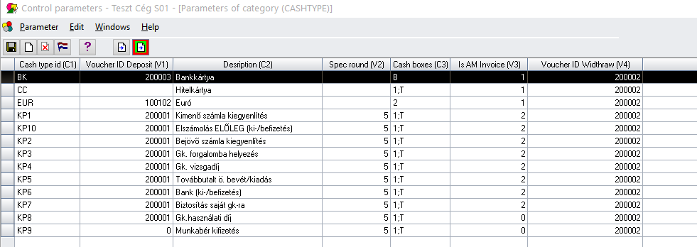

V1: voucher id when deposit, V4 when withraw

V2: rounding

V3: If V3=1 then this cashtype is showed only when double click on an invoice in Seach invoice window, V3 =0 then this cashtype is showed only when click New payment.

V3 =2 then the cashtype will always be showed

V5=0 --> available for both Deposit and Withdraw  
V5=1 --> available for only Deposit (Deposit radio button is selected)  
V5=2 --> available for only Withdraw (Withdraw radio is selected)

Card types are defined in CASHCCTYPE, they can be selected only when the CASHFORM = CREDITCARD

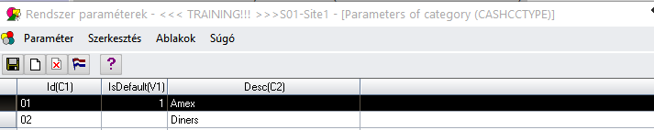

Other controldata settings:

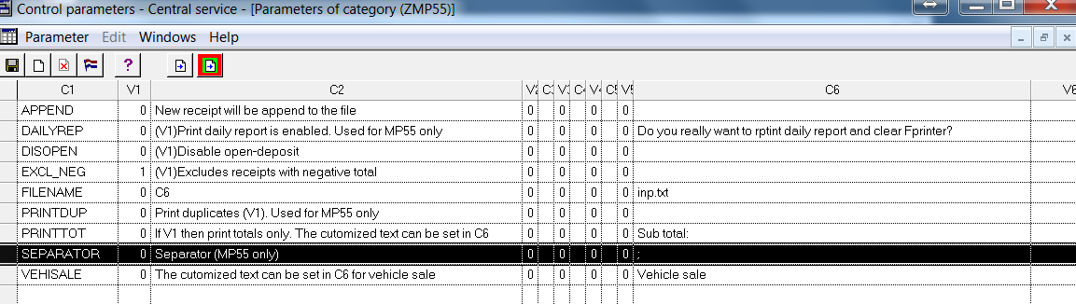

EXCL_CRED exclude credit notes

In the following controldata you should create the mapping from AM to fiscalprinter.

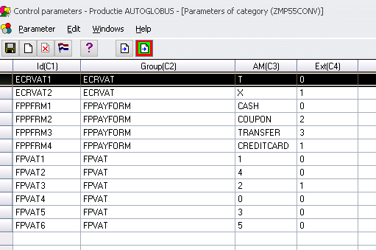

BUG in AM is fixed : The error is that the sum amount from GROW/SROW is not the same as the amount from CASHTRANS ( VAT rounding ) at the fraction 0.01. The consequence was the printer gave error claiming the total of lines is not equal to the receipt total. The needed control data settings are:

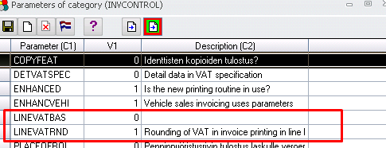

Database tables:

* CASHBOX: cash box status (ISOPEN=1 then open, ISOPEN=1 then closed)
* CASHBOXPC: link between a cash box and a PC. When user logins to application via Remote desktop, the computer name (CASHBOXPC.PC column) is the name of client computer, not the name of RDP server.
* CASHTYPE: definition of cash types (see above).
* CASHREG: table store the cash box opening and closing transactions (header table)
* CASHREGROW: table store the row data linked to CASHREG (detail table)
* CASHTRANSH: payment transaction header
* CASHTRANSR: payment transaction rows

Unpaid AM invoices will be searched from a full text search indexed view: ASVIEW_CAREG_UNPAID_INVOICE

Paid invoices will be searched from a full text search indexed view: ASVIEW_CAREG_PAID_INVOICE

# Development needs

## Login screen – Existing functionality

Following login screen and existing application authentication module must be used.

Login screen is shown at application start up.

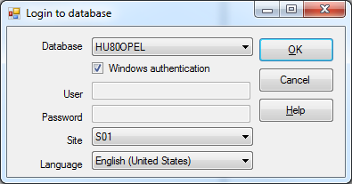

## Main screen

Main screen with 3 function button

* to Open cash box
* to Close cash box
* to Search invoice and perform payment

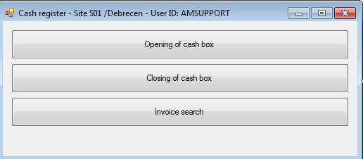

## Opening of cash box

Cash box has to be opened at starting of the day. A cashier can open and work with several cash boxes at the same time. But only one cashier can work on a cash box, in other words, application does not allow 2 cashers to work on same cash box.

Status of a cash box is Opened if CASHBOX.IS0PEN =1, status of cash box is Closed if

* CASHBOX.ISOPEN=0
* or the record with cash box id does not exist at all in table CASHBOX (when new cash box is created in parameter)

A cashier (a PC) is linked to a cash box in table CASHBOXPC. There can be several rows with same PC and different cash box id, but one cash box is linked to one PC at same time.

Note: a cash box can be opened and closed several times in one day. For example Cashier A opens the cash box at 8:00 and closes it at 12:00, after that Cashier B opens the same cash box from 13:00 and closes it at 17:00.

Following window will be shown to user when click Opening of cash box menu from main screen.

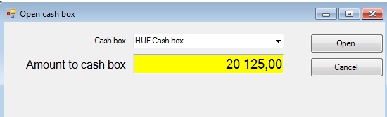

**Description of fields**

|  |  |
| --- | --- |
| Field | Description |
| Cash box combo box | Combo box is filled with cash box name from control data CASHBOXID | C2.  Only closed cash boxes are shown in combo box (Opened cash boxes are not show in the combo box) |
| Amount to cash box | Opening balance for local currency cash.  Default value of this field will be zero |
| Open button | Peform opening of cash box.  Button is enabled only if a cash box id is selected from combo box.  If all cash boxes are opened (the combo box is empty) then the button should be disabled  When button is clicked, there will be a check if the opening balance entered by user is same than the closing balance of previous cash box closing transaction.  This can be done by:   * checking the latest closing transaction in table CASHREG (using time stamp UPDATED_DATE), column CASHREG.EVENT=C. If no any transaction exist (cash box is never closed) then the previous closing balance = 0 * Then check in table CASHREGROW (link with CASHREG by CASHREGROWID) and find the line where CASHFORM=CASH. The closing balance value is stored in column CASHREGROW.AMOUNT.   If the amount does not match, then a message box is shown to user:  Balance mismatched …  If the amount does match, then the cash box will be closed:   * insert a line to table CASHBOX, if it does not exist * update CASHBOX.ISOPEN=1 * insert a row to table CASHBOXPC (link the cashier PC with cashbox id) * insert a row to table CASHREG with EVENT code = O * insert a row to table CASHREGROW with   + CASHFORM=CASH   + CASHTYPE=a constant defined in config file (HUF)   + AMOUNT = the opening amount entered by user   if transaction is commited then the cash box is Opened.  The window is closed after opening of cash box is success |
| Cancel button | Close window, do nothing |

## Closing of cash box

At end of day, the cash box is closed and the cashier is released. The total amount of transactions created from latest cash opening is summarized and saved.

The cash box can be closed only from the same work station from which it was opened. Exception is if the user has extended db right (set in ykay) then he can close from any work station.

In addition, denomination details of cash (local currency) and foreign currencies must be calculated and it should match the total amount.

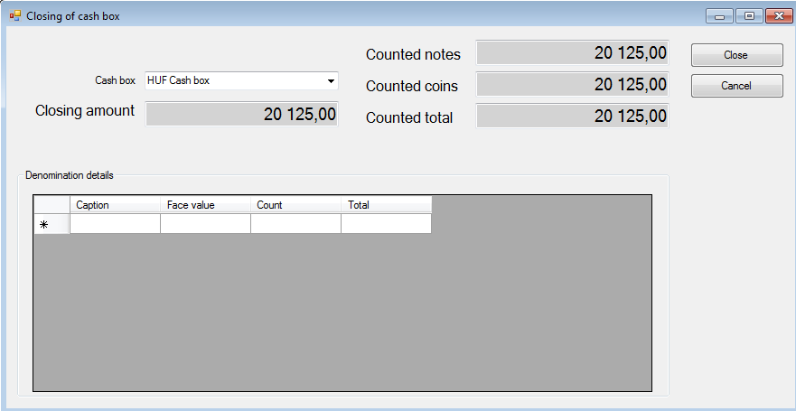

Example data

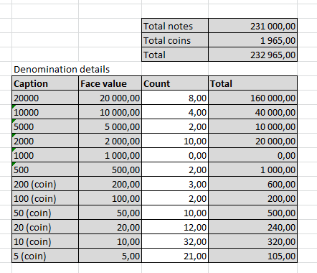

Cash denomination settings.

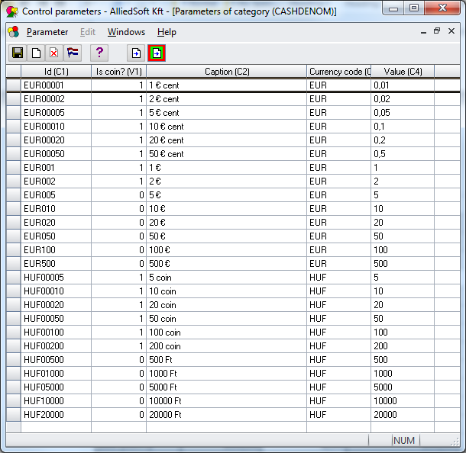

## Invoice search window

In this window, user can enter some search criteria, search the invoices, select one invoice in the grid and click button Invoice payment to create payment transaction on it, if the invoice is not Paid.

If the payment transaction is paid, then user can open it for viewing, reprinting by double click to the row in grid.

Unpaid AM invoices will be searched from a full text search indexed view: ASVIEW_CAREG_UNPAID_INVOICE

Paid invoices will be searched from a full text search indexed view: ASVIEW_CAREG_PAID_INVOICE

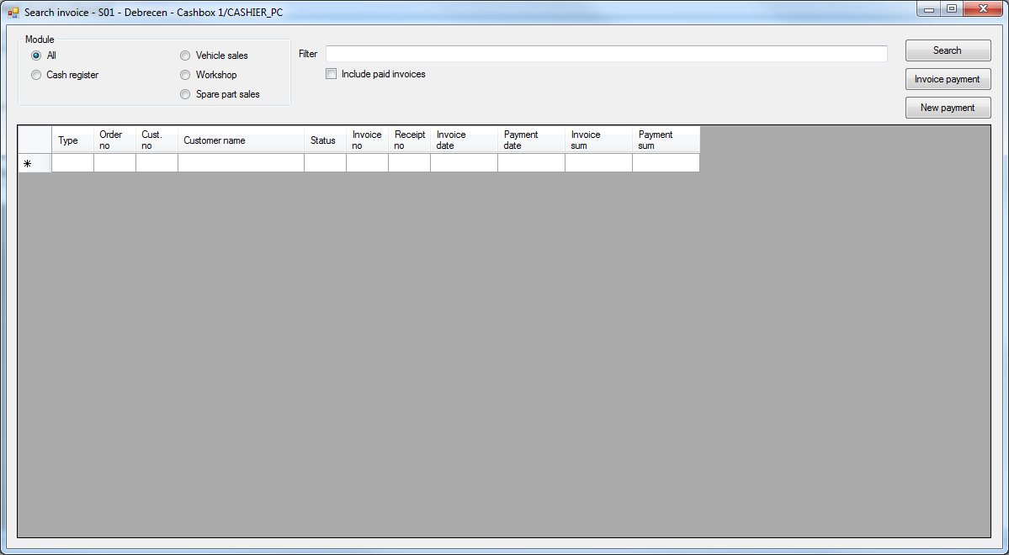

**Description of fields**

|  |  |
| --- | --- |
| Name | Description |
| Search modules |  |
| Vehicle sales | Search vehicle sales invoice/receipt  Unpaid invoice: ASVIEW_CAREG_UNPAID_INVOICE.APPAREA=A  Paid invoice: ASVIEW_CAREG_PAID_INVOICE.MODULE=VA |
| Workshop | Search workshop invoice/receipt  Unpaid invoice: ASVIEW_CAREG_UNPAID_INVOICE.APPAREA=G  Paid invoice: ASVIEW_CAREG_PAID_INVOICE.MODULE=WO |
| Spare part sales | Search spare part invoice/receipt  Unpaid invoice: ASVIEW_CAREG_UNPAID_INVOICE.APPAREA=S  Paid invoice: ASVIEW_CAREG_PAID_INVOICE.MODULE=SP |
| Cash register | Search transaction not related to AM invoice, only paid invoice option  Paid invoice: ASVIEW_CAREG_PAID_INVOICE.MODULE=anything other than VA, WO, SP |
| All | Search from all modules above |
| Other search criteria |  |
| Filter | Full text search filter. The views are full text search indexed view |
| Include paid invoice | If option is ticked, then application searches data also from view ASVIEW_CAREG_PAID_INVOICE  Otherwise it searches only from ASVIEW_CAREG_UNPAID_INVOICE  Check box is not ticked by default when application is opened |
| Search button | Execute search and display the result to the grid |
| Search result grid |  |
| Type | Text description of module name:  Vehicle sales  Workshop  Spare part sales  Cash register |
| Order no | Order number  ASVIEW_CAREG_UNPAID_INVOICE.ORDNO  ASVIEW_CAREG_PAID_INVOICE.ORDNO |
| Custno | Order number  ASVIEW_CAREG_UNPAID_INVOICE.CUSTNO  ASVIEW_CAREG_PAID_INVOICE.CUSTNO |
| Customer name | Customer name  ASVIEW_CAREG_UNPAID_INVOICE.LNAME +’ ’ + FNAME  ASVIEW_CAREG_PAID_INVOICE.LNAME+’ ’ + FNAME |
| Status | Paid or unpaid |
| Invoice no | Invoice number  ASVIEW_CAREG_UNPAID_INVOICE.RECNO  ASVIEW_CAREG_PAID_INVOICE.RECNO |
| Receipt no | Receipt number, only for paid invoice  ASVIEW_CAREG_PAID_INVOICE.RECEIPTNO |
| Invoice date | Invoice date  ASVIEW_CAREG_UNPAID_INVOICE.BILLD  ASVIEW_CAREG_PAID_INVOICE.BILLD |
| Payment date | Payment date, only for paid invoice  ASVIEW_CAREG_PAID_INVOICE.PAYDATE |
| Invoice sum | Invoice sum  ASVIEW_CAREG_UNPAID_INVOICE.INVSUM  ASVIEW_CAREG_PAID_INVOICE.AMOUNTTOPAY |
| Payment sum | Payment sum, only for paid invoice  ASVIEW_CAREG_PAID_INVOICE.TOTPAID |
| Invoice payment button | Click this button will   * open Payment dialog to make new payment if selected line in grid is an unpaid invoice * open Payment dialog to show existing transaction if selected line in grid is a paid invoice * if line is not selected, button is disabled |
| New payment | Click this button will open Payment dialog to make new payment without an invoice from AM. |

## Payment window

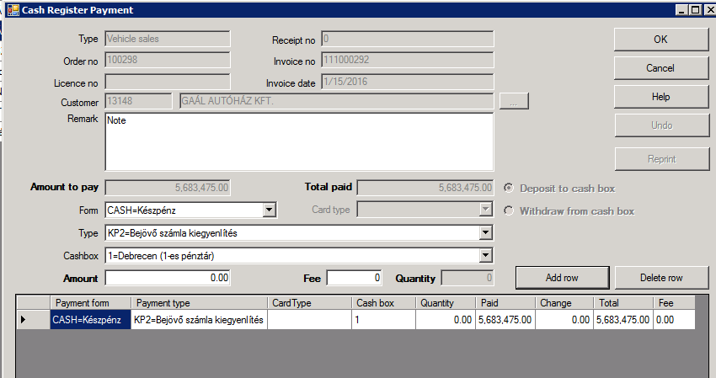

**Description of fields**

|  |  |
| --- | --- |
| Name | Description |
| OK button | Create and print the receipt/ generate the receipt file |
| Undo button | Create a credit receipt. This button enabled only if the CashBox is opened and from the same workstation where it was paid. Always enabled in case of virtual cashbox |
| Add row button | Add a payment row |
|  |  |

### Printing of cash payment voucher

## New reports

Change history:

2016.04.01

1.It is now time to implement Customer search to CashRegPrime.  
Please add a small button (...) next to the Customer Name field  
The button will open a popup window. In that window  
- there is a search criteria field (full text)  
- a grid display result (customer number, last, first name, phone number, address, email)  
- Button Search (default enter), search from FTVIEW_CUST  
- select by double click  
- Cancel button (escape)  
2.

There will be several credit card terminal that is used by multiple cashier.  
They will be created as virtual cash box and we should allow several users to use it.  
So if one opens the cash box, any other can pay to it.  
Pls make the change in Cashregprime to allow this.  
There will be a flag in CASHBOXID parameter (V6) to allow this. We will allow only for virtual cash box, not the real cash box.

2016.04.25

Hi,

Please add possibility to add Fee in cash register when payment type is card

We will set in CASHBOXID the V10=1, if fee is applied

Then if V10=1 the field will be enabled.

Save to CASHTRANSR.FEE

Pls make the change and deploy to Avtotehna

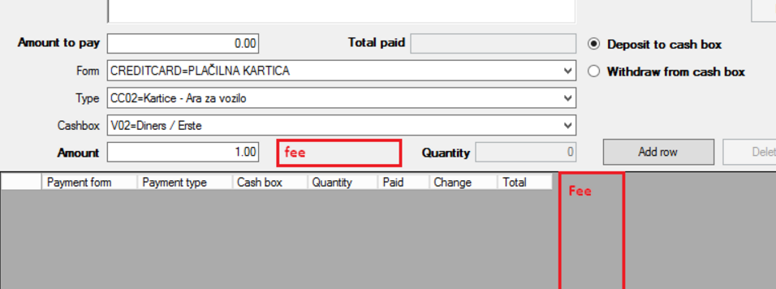

2016.05.20

<add key="WinCodepage" value="1251" />  
If defined, this code page will be used to export fiscal receipt file. If not, the default codepage is used.

2016.05.20

Hi,  
We need 2 CR for Cash reg prime  
  
1) Today CASHTYPE/V3 defines if the cash type is available for  
1= for invoice   
0=for other payment   
2=for both  
We need a new setting in column V5, this will be applied for other payment (not other payment)  
V5=0 --> available for both Deposit and Withdraw  
V5=1 --> available for only Deposit (Deposit radio button is selected)  
V5=2 --> available for only Withdraw (Withdraw radio is selected)  
  
2) Define the credit card type.   
Today we have each cash box for each card type (Amex, Diners etc...). But the cash boxes will be user specific (will be like Cash)  
We need additional combo box field to define the Card type.   
The Form combo box will be shorter and the Card Type combo box will be next to it in the right.  
Combo box is enabled only when Credit card form is selected.  
Combo box is filled from a new control data (CASHCCTYPE, C1 and C2 column)  
Selected value shall be added to row and saved in CASHTRANSR.CC_TERMINALID

2016.05.26

ZFP55, ZMP55 control data

EXCL_CRED : creditnote is not print to the file

2016.10.19

SSRS receipt print will not use the bat file P_..., but shows PDF file directly.

If Windows autentication AND the rsUserName/password is not set then program will use windows autentication to connect to SSRS service. This scenario works if the program and the SSRS service are on the same computer(Adria Plus). IN THIS CASE DONT set rsUser/password

If windows autentication and the program and the SSRS service are on different comupters /or windows autentication does not work then the rsUserName/password/Domain should be set correctly

<!--SSRS service url-->

<add key="rsExecUrl" value="http://asrd1/ReportServer_SQLEXPRESS2014/"/>

<add key="rsExecService" value ="reportexecution2005.asmx"/>

<add key="rsCashReceiptReport" value="/IVECO81 Allied Reports/Report Definitions/AMCTR61 - Cash Receipt"/>

<add key="rsFormat" value="PDF"/>

<!--SSRS service file path,where the rendered files are created-->

<add key="rsFilePath" value="c:\AMW\Wrk\AlliedFeatures\CashRegPrime\SSRSFilePath\"/>

<!--SSRS service user name ,password. Used if not windows autentication-->

<add key="rsUserName" value="trung.nguyen"/>

<add key="rsPassWord" value="Master1*"/>

<add key="rsDomain" value=""/>

2016.12.19

New checkbox Show also credited. At Avtotechna sometimes they want to pay a partly credited invoices

2017.06.13

Bug: After adding Rows, if the user changes the Radio button (Withraw/Debit) then the cashtype can be invalid.

Fix: Disable the radio button if there is Rows

2017.08.10

Insert Rouding lines (Hungary specific):

If the amount is not rounded (to 5) then add rounding line- Positive and negative line will have different cashtype, which are defined in config file and CASHTYPE table/ CASHTYPE control data

1. add to table CASHTYPE

insert into CASHTYPE (INUSE,FORM,TYPE,CODE,SALETYPE,DESCRIPTION,UPDATED_DATE,UPDATED_BY ) values (1,'CASH','ZRDP','ZRDP','CA','Kerekítés pozitív', GETDATE(),'SUPPORT')

insert into CASHTYPE (INUSE,FORM,TYPE,CODE,SALETYPE,DESCRIPTION,UPDATED_DATE,UPDATED_BY ) values (1,'CASH','ZRDN','ZRDN','CA','Kerekítés negatív', GETDATE(),'SUPPORT')

2. Ad to config file:

<add key="RoundingCashTypePositive" value="ZRDP"/>

<add key="RoundingCashTypeNegative" value="ZRDN"/>

3.Add to control data cashtype ZRDP, ZRDN with V2 =5, V3=-1, V5 = 0